**ASSIGNMENT 24.5**

* Using database
* Database which is already created has been used here.

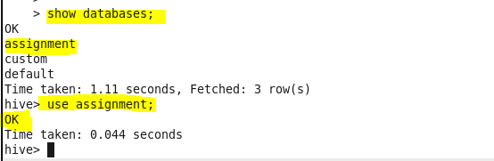

* Creating table with all the necessary columns.

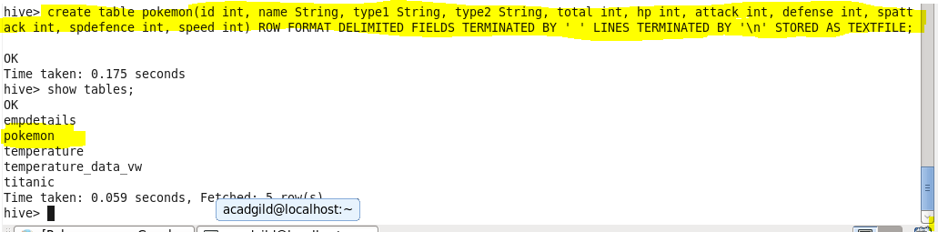

* Loading data from data file directory into the pokemon table.

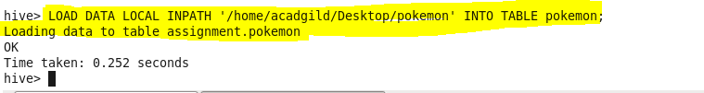

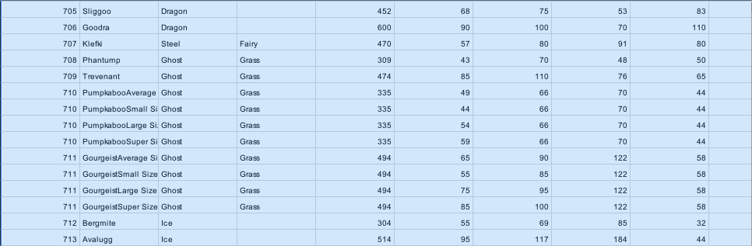

* **Find out the average HP (Hit points) of all the Pokémons**

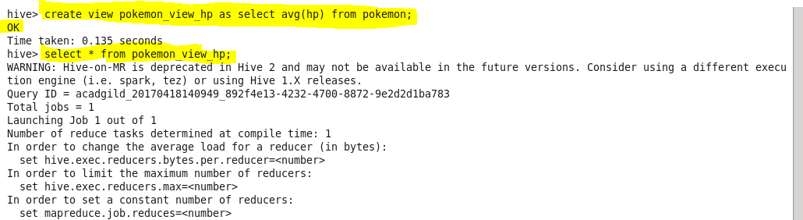

**Output:**

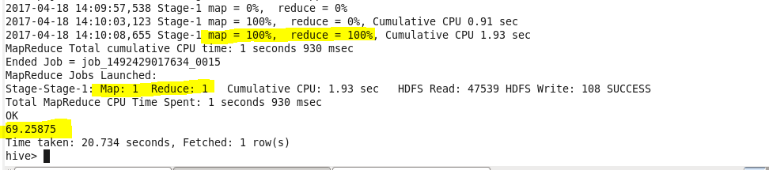

* **Find out the average Defense of all the pokemon**

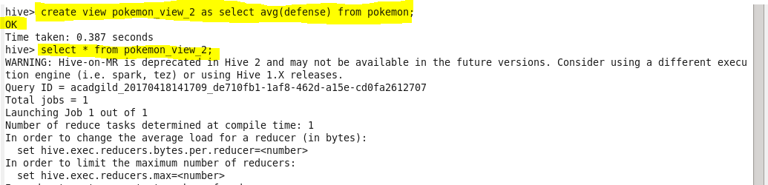

**OUTPUT:**

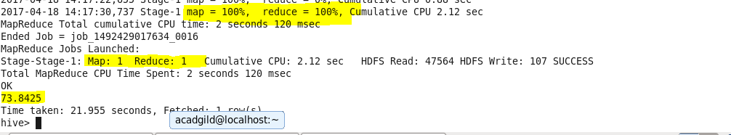

* **Find out the average Sp.Atk of all the pokemons**

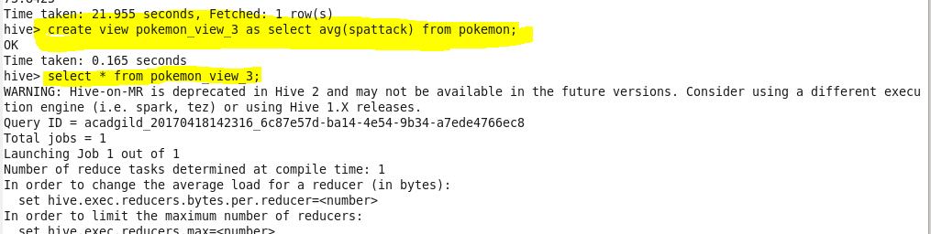

**Output:**

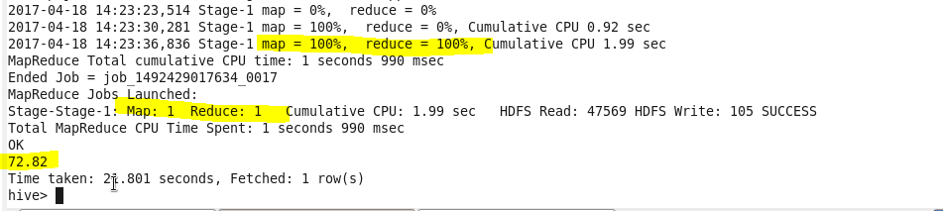

* **Find out the average sp.Def of all the pokemons**

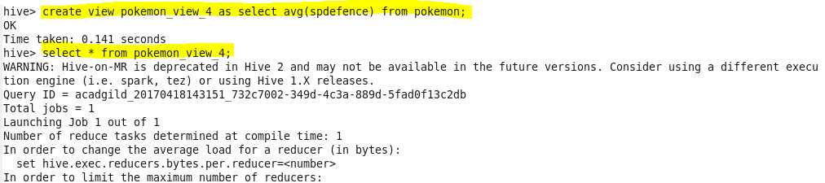

**Output:**

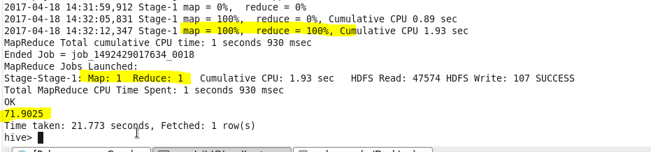

* **Find out the average Speed of all the pokemons**

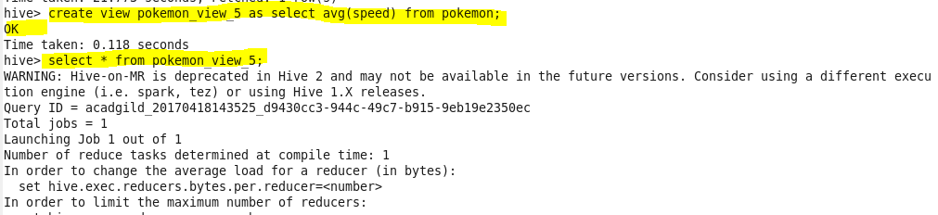

**Output:**

